FLUIDS
Two important things to consider are - ensuring individual targets have been set for all the service users in the Administration and making sure that all staff are acquainted with how to use the new function on the front-end.
Once this has been done, the Fluid form should be disabled, so all staff are registering fluids in the same place.

In the Administration:
Within Setup, you will see a Fluid tab, where you will be able to make a selection of residents and set (and amend) new targets as required.

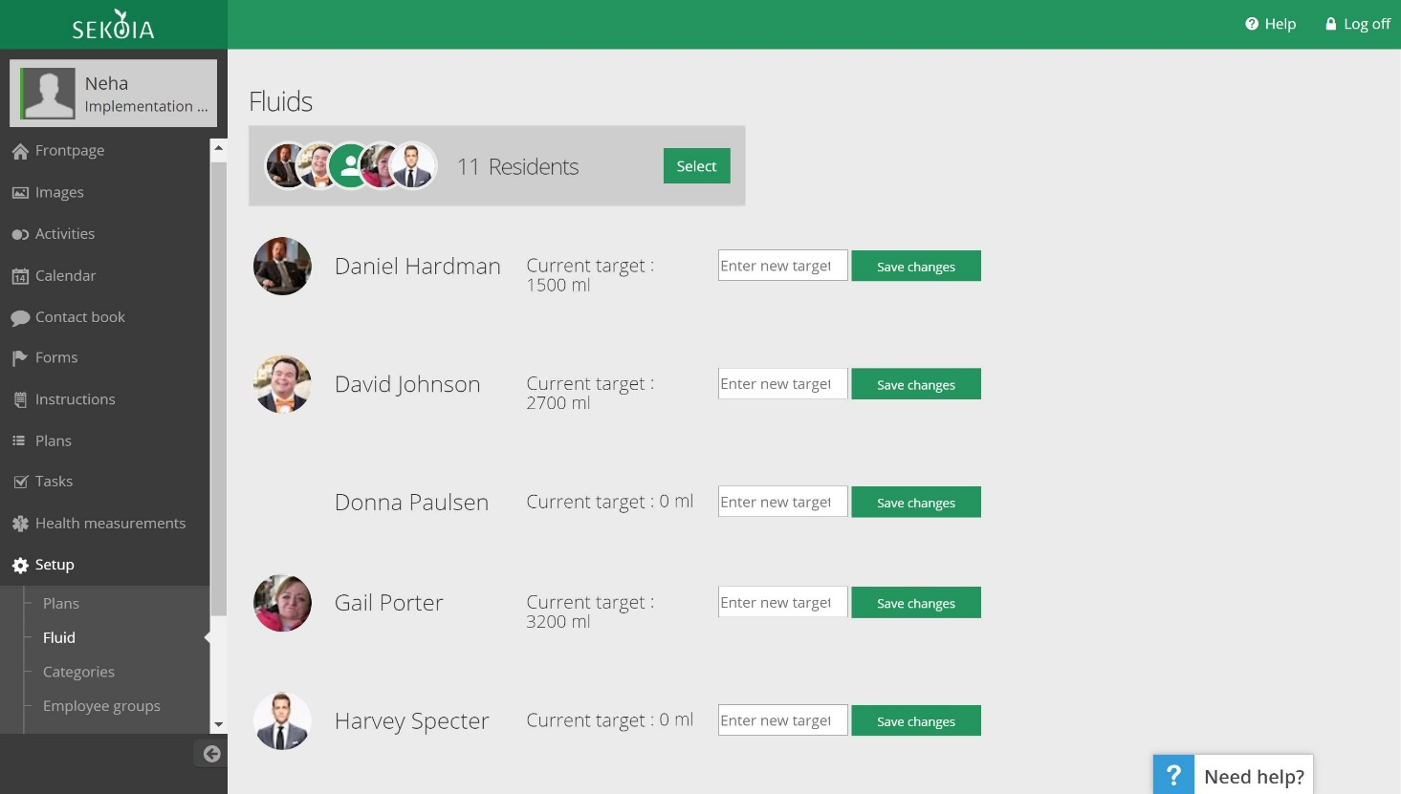

On the Front-end:
On the care delivery list, if you click on ‘Create’ you will see a tab for ‘Fluids’ and be able to make the registration for Fluids.

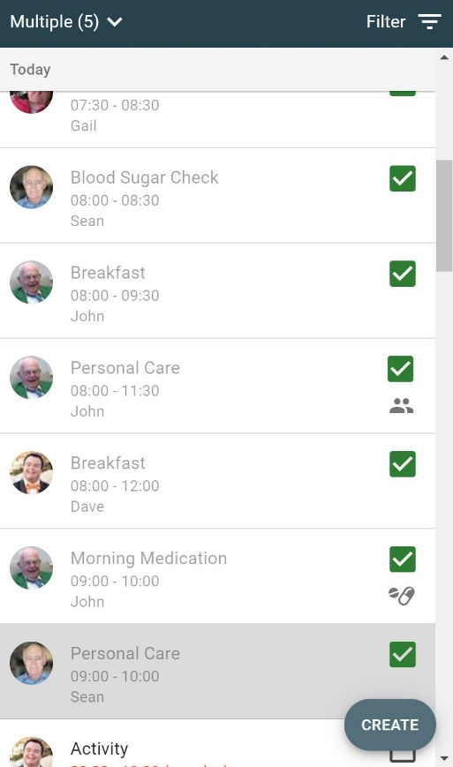

The registration can be made in two ways. You can either register what you have offered, knowing that this is the same amount that has been consumed.

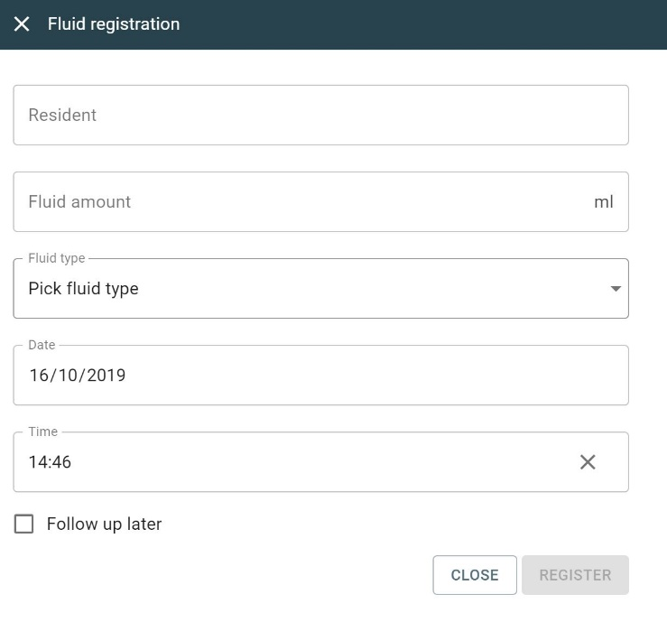

Or having offered the fluid, you may need to follow up later to see if this has been consumed entirely, in which case you can schedule a follow-up for later. A new task will then be created at the time of follow-up. You can then return to this and enter the amount that has been consumed, along with the option of adding a comment if needed. This is shown below:

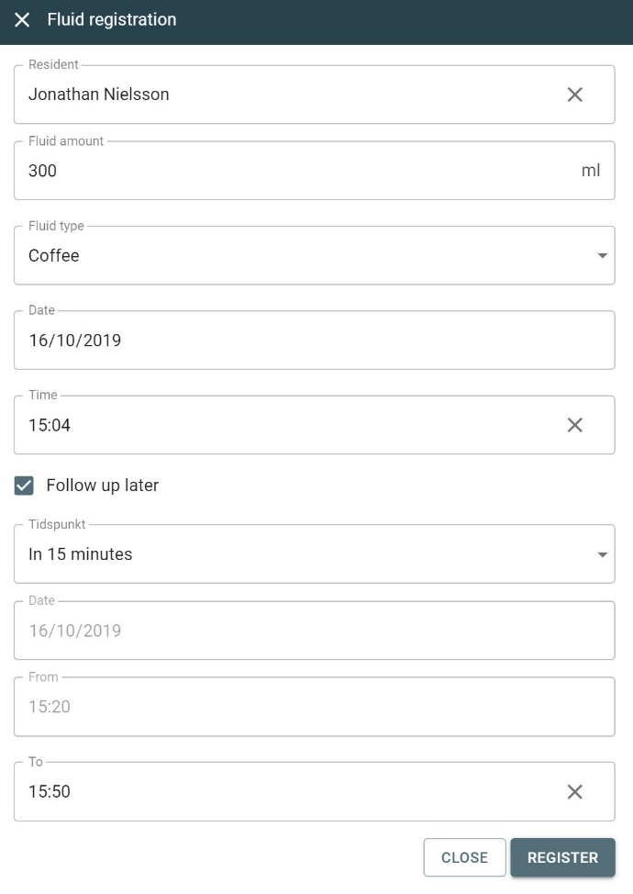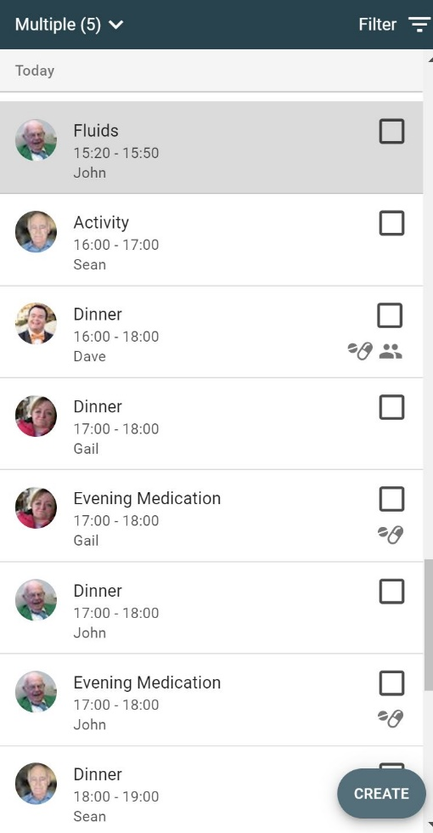

Fluid Overview:
An overview of Fluid consumption can be obtained in two ways. To access this information for an individual resident, you will see a new tab called ‘Fluids’ next to Tasks as shown in the picture below:

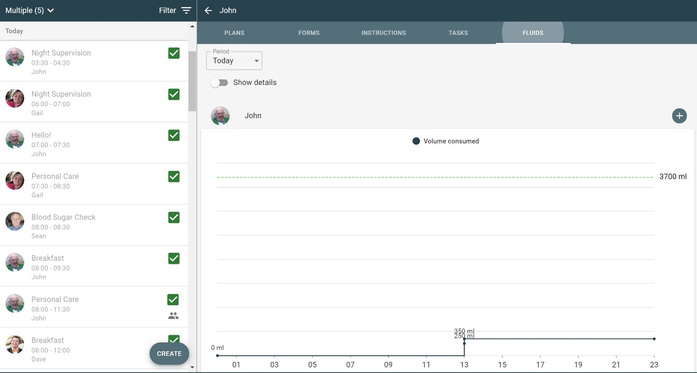

To access the same information collectively for all your residents, you can select the ‘Overview’ button at the bottom of the device. You will see a new tab called ‘Fluids’ next to Forms where you can access this information together for all the residents you select.

